PRACTICAL NO.6
Programming menus, dialog, dialog fragments
Code:
activity_main.xml
<?xml version="1.0" encoding="utf-8"?>
<androidx.constraintlayout.widget.ConstraintLayout xmlns:android="http://schemas.android.com/apk/res/android"
xmlns:app="http://schemas.android.com/apk/res-auto"
xmlns:tools="http://schemas.android.com/tools"
android:layout_width="match_parent"
android:layout_height="match_parent"
android:id="@+id/mylay"
tools:context=".MainActivity">
<Button
android:id="@+id/button"
android:layout_width="wrap_content"
android:layout_height="wrap_content"
android:text="Menu"
app:layout_constraintBottom_toBottomOf="parent"
app:layout_constraintEnd_toEndOf="parent"
app:layout_constraintHorizontal_bias="0.498"
app:layout_constraintStart_toStartOf="parent"
app:layout_constraintTop_toTopOf="parent"
app:layout_constraintVertical_bias="0.175" />
<Button
android:id="@+id/button2"
android:layout_width="wrap_content"
android:layout_height="wrap_content"
android:text="Color Change Dialog"
app:layout_constraintBottom_toBottomOf="parent"
app:layout_constraintEnd_toEndOf="parent"
app:layout_constraintHorizontal_bias="0.498"
app:layout_constraintStart_toStartOf="parent"
app:layout_constraintTop_toTopOf="parent"
app:layout_constraintVertical_bias="0.364" />
<Button
android:id="@+id/button3"
android:layout_width="wrap_content"
android:layout_height="wrap_content"
android:text="Custom Dialog"
app:layout_constraintBottom_toBottomOf="parent"
app:layout_constraintEnd_toEndOf="parent"
app:layout_constraintHorizontal_bias="0.498"
app:layout_constraintStart_toStartOf="parent"
app:layout_constraintTop_toTopOf="parent"
app:layout_constraintVertical_bias="0.559" />
</androidx.constraintlayout.widget.ConstraintLayout>

MainActivity.kt
package com.example.firstdemo
class MainActivity : AppCompatActivity() {
override fun onCreate(savedInstanceState: Bundle?) {
super.onCreate(savedInstanceState)
setContentView(R.layout.activity_main)
//on button press menu
button.setOnClickListener {
var mymenubtn=PopupMenu(this,button)
menuInflater.inflate(R.menu.my_menu,mymenubtn.menu)
mymenubtn.show()
mymenubtn.setOnMenuItemClickListener(
PopupMenu.OnMenuItemClickListener { it ->
when(it.itemId){
R.id.i1->mylay.setBackgroundColor(Color.CYAN)
R.id.i2->Toast.makeText(this,"Hello SRM",Toast.LENGTH_SHORT).show()
R.id.i3->System.exit(0)
}
true
}
)
}
//on button pressed dialog
button2.setOnClickListener {
var alert_box=AlertDialog.Builder(this)
alert_box.setTitle("Change Color")
alert_box.setMessage("Do you want change color?")
alert_box.setPositiveButton("Yes"){
alert_box,it->mylay.setBackgroundColor(Color.YELLOW)
}
alert_box.setNegativeButton("No"){
alert_box,it->Toast.makeText(this,"No Change",Toast.LENGTH_SHORT).show()
}
alert_box.setNeutralButton("Nothing"){
alert_box,it->Toast.makeText(this,"Nothing",Toast.LENGTH_SHORT).show()
}
alert_box.create()
alert_box.show()
}
//Custom dialog
button3.setOnClickListener {
var obj=MyOwnDialog()
obj.show(supportFragmentManager,"MyDialog")
}
}
//on back press dialog
override fun onBackPressed() {
var alert_box=AlertDialog.Builder(this)
alert_box.setTitle("Close")
alert_box.setMessage("Do you want close app ?")
alert_box.setPositiveButton("Yes"){
alert_box,it->System.exit(0)
}
alert_box.setNegativeButton("No"){
alert_box,it->Toast.makeText(this,"No Change",Toast.LENGTH_SHORT).show()
}
alert_box.setNeutralButton("Nothing"){
alert_box,it->Toast.makeText(this,"Nothing",Toast.LENGTH_SHORT).show()
}
alert_box.create()
alert_box.show()
}
//Simple menu
override fun onCreateOptionsMenu(menu: Menu?): Boolean {
menuInflater.inflate(R.menu.my_menu,menu)
return true
}
override fun onOptionsItemSelected(item: MenuItem): Boolean {
if(item.itemId==R.id.i1){
mylay.setBackgroundColor(Color.MAGENTA)
}
if(item.itemId==R.id.i2){
Toast.makeText(this,"Hello SRM",Toast.LENGTH_SHORT).show()
}
if(item.itemId==R.id.i3){
System.exit(0)
}
return true
}
}

my_menu.xml:
<?xml version="1.0" encoding="utf-8"?>
<menu xmlns:android="http://schemas.android.com/apk/res/android">
<item android:id="@+id/main"
android:title="Main Menu">
<menu>
<item android:id="@+id/i1"
android:title="Change Color"/>
<item android:id="@+id/i2"
android:title="Toast"/>
<item android:id="@+id/i3"
android:title="Exit"/>
<item android:id="@+id/dis"
android:title="Option"
android:enabled="false" />
</menu>
</item>
</menu>

my_dialog.xml:
<?xml version="1.0" encoding="utf-8"?>
<AbsoluteLayout xmlns:android="http://schemas.android.com/apk/res/android"
android:layout_width="match_parent"
android:layout_height="match_parent">
<EditText
android:layout_width="300dp"
android:layout_height="wrap_content"
android:id="@+id/txt"
android:hint="Enter your data:"/>
<Button
android:layout_width="wrap_content"
android:layout_height="wrap_content"
android:id="@+id/btnsubmit"
android:layout_x="120dp"
android:layout_y="50dp"
android:text="Submit"/>
</AbsoluteLayout>

MyOwnDialog.kt:
package com.example.firstdemo
class MyOwnDialog:DialogFragment() {
override fun onCreateView(
inflater: LayoutInflater,
container: ViewGroup?,
savedInstanceState: Bundle?
): View? {
var main=inflater.inflate(R.layout.my_dialog,container)
main.btnsubmit.setOnClickListener {
var data=main.txt.text.toString()
Toast.makeText(context,data,Toast.LENGTH_SHORT).show()
}
return main
}
}

Output:
Simple Menu and Button Menu -
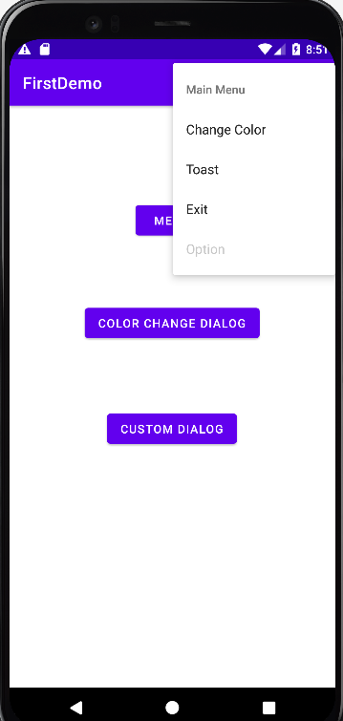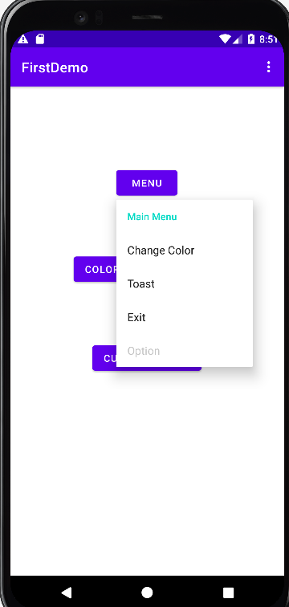

Button Pressed simple Alert Dialog Box-
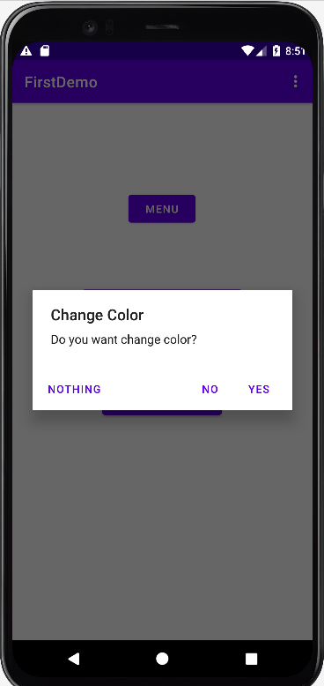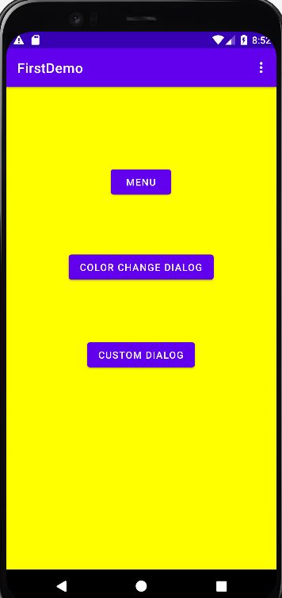

BackPress Alert Dialog Box-

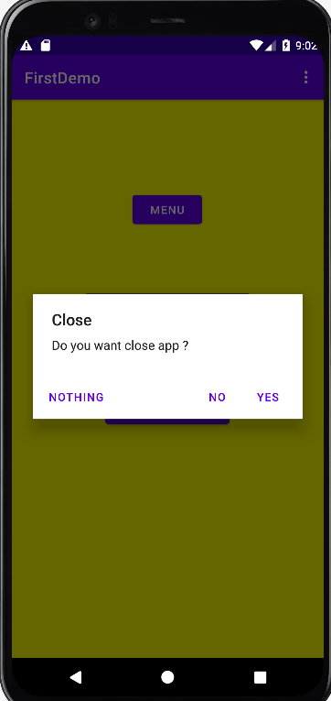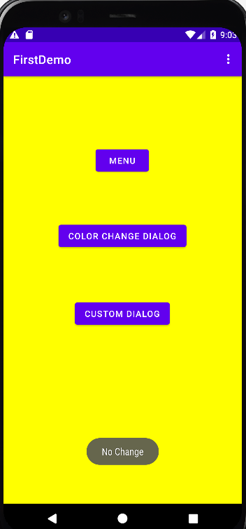

Custom Dialog Box-
